**Abstract and Introduction**

We have made a game called ‘Plants VS Zombies’. In this game the zombies invade the plants and try to reach their territory. The zombies will come from the left side of the screen and their motive is to reach the left side of the screen by destroying the plants which come in their way by reducing their lives.

In order to stop the zombies to reach the left side of the screen, we have three plants to defend our side, i.e. the Shooter Plant, the Sunflower Plant and the Walnut plant.

We have to plant these plants in the main arena in order to stop the zombies. In order to do this the user, have to click on any one of the plants at the left side of the screen and then click on the grid of the arena where the user wants to plant it.

We also have a currency in this game called – ‘Sun’. Each plant has a cost of certain amount of ‘Sun’. When the user plant a plant then the corresponding ‘Sun’ will get deducted from the ‘Sun’ currently available to the user. If for a particular plant the user does not have enough ‘Sun’ then the grid of that plant will highlight in red otherwise it will highlight in green (means the user has enough ‘Sun’ to plant that plant). If the grid is red and the user still insists on planting then he will be notified that he does not have enough ‘Sun’

Initially at the starting the user will get 50 ‘Sun’.

The task of the Shooter plant is to shoot the zombies with pea bullets at regular intervals of time. The pea bullet will damage the zombies and reduce their health. The Shooter plant will shoot only if there is a zombie in front of it otherwise it will remain idle and will not shoot. Once the zombie gets 5 bullets it gets destroyed and the current health of the zombie is shown above its head. The cost of the Shooter plant is 100 ‘Sun’

The user will get 50 ‘Sun’ in every five seconds automatically from the system. But there is Sunflower plant which will boost up this process. When planted, each sunflower plant will produce 25 ‘Sun’ every 5 seconds. The cost of the Sunflower plant is 50 ‘Sun’.

The Sunflower and the shooter plant have some life, they can hold the zombies but for a very short time. Once their life becomes zero by the zombies they get destroyed.

But there is one plant called the Walnut Plant, which stops the zombies in its way for a longer period of time as it has larger life. It is basically used to stop the zombies for some time so that the Shooter plant can destroy them. The cost of the Walnut plant is 50 ‘Sun’.

The game involves 2 levels. In the first level there are 10 zombies which the user has to defeat and the rate of spawning of zombies is a little bit slow. If the user defeats all the 10 zombies of the level 1 he is promoted to level 2. In level 2, there are 20 zombies in total to defeat and the rate of zombie spawning increases, making it difficult for the user to defend against the zombies. In either level if a zombie manages to touch the grey part at the left side of the screen then the player loses and game gets over and a screen of ‘Game Over’ is shown.

**System Requirements**

The following system requirements are needed to run the game:

* The size of the game is 1.6MB including the image files.
* The user needs to have installed python and pygame in his system.
* The user should have a terminal to run the python code.
* The user should also have the required images for the game in the same repository as the python file.

**Flowchart**

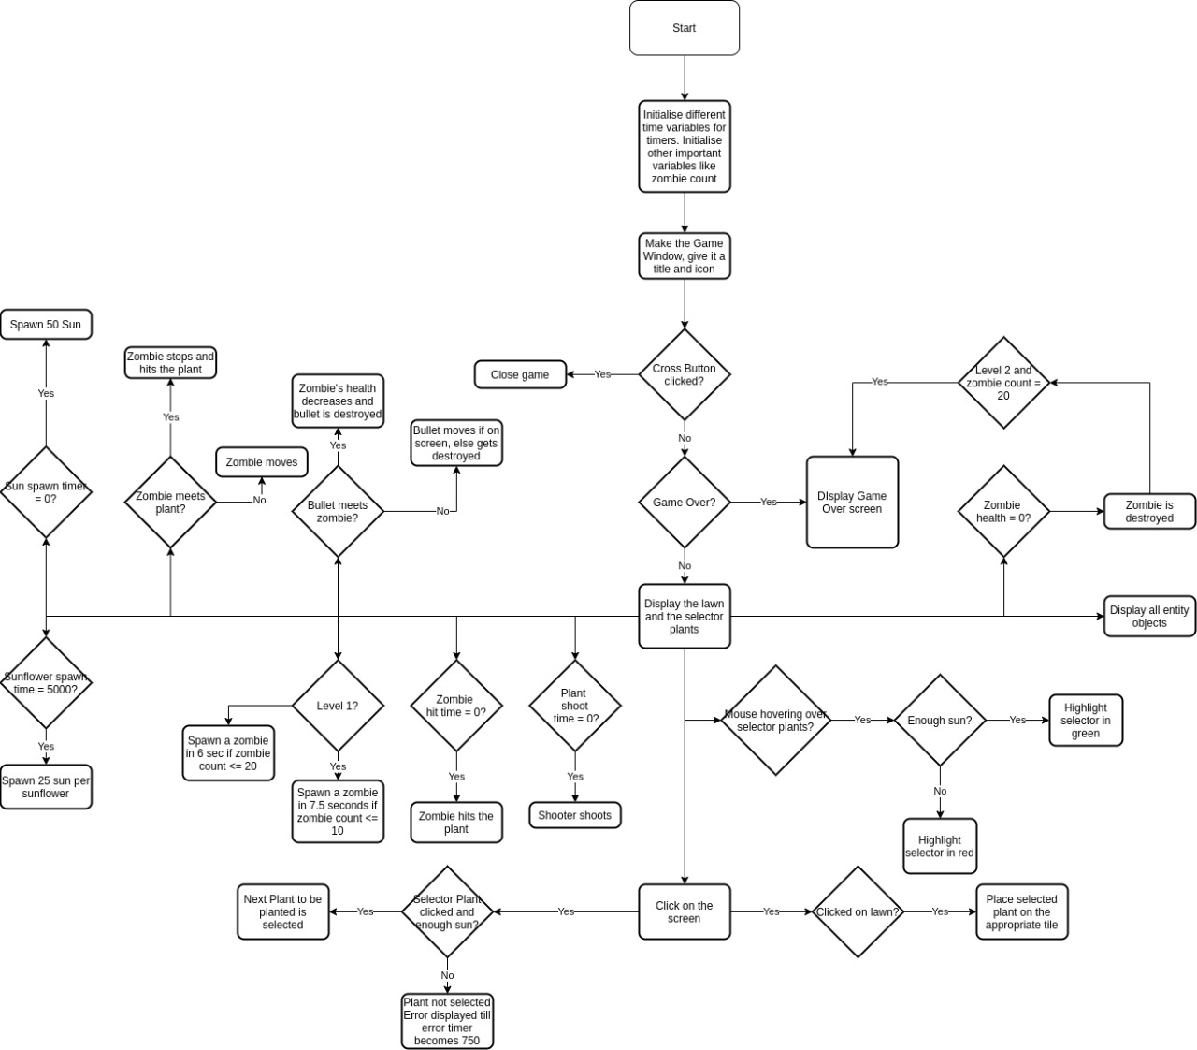

**Future Aspects**

* Planning to increase the number of levels, different types of plants and increase in the difficulty of game.
* Adding of sounds and animations to the game.
* In the present version, free suns are generated at regular intervals, we need to upgrade this to, falling of free suns from the top of the screen and placing on the garden area and when we click on the suns it is supposed to increase of currency.
* Similarly, suns coming from the sunflower plant are getting added automatically to the currency, we need to also upgrade this. After planting sunflowers in the garden area, at regular intervals of time the suns are generating, these suns need to display around it and when we click on the suns it is supposed to increase the currency.

**References**

We referred to the following resources for the Project:

* The actual game of Plants versus Zombies.
* <https://www.youtube.com/watch?v=FfWpgLFMI7w>

A Youtube video which implemented a spaceship game, much similar to our idea of the PlantsVsZombies game. This video helped us on how to create enemies and shoot them with bullets.

* <https://www.geeksforgeeks.org/introduction-to-pygame/>

From this GeeksForGeeks article, we learnt the basics of Pygame and it’s functionality to get started.